bWAPP VAPT  Assessment | VULNERABILITY REPORT | Report id : 2026-001  Date : 17 june  Tester : Abhijeet

 1 Vulnerability name | HTML Injection - Reflected (GET)
 2 severity level | low
 3 CVSS Score | 3.5 (low)
 4 Discription | A Reflected HTML Injection vulnerability was identified in the HTML Injection - Reflected (GET) functionality of the bWAPP application. The application attempts to prevent HTML injection by filtering special characters such as angle brackets (< and >). However, the implemented protection can be bypassed by URL-encoding the malicious payload before submission.  The application decodes the supplied input and renders it within the browser without proper output encoding, resulting in successful execution of arbitrary HTML content.
 5 Affected Function / Parameter | Login page , first name and last name
 6 Vulnerability Discovery Methodology | Reconnaissance  The HTML Injection - Reflected (GET) functionality was identified as a potential attack surface due to direct reflection of user-supplied input.  Input Validation Testing  The following payload was initially submitted:  <h1>Hello</h1>  The application attempted to block the payload by filtering HTML-specific characters.  Filter Bypass Testing  The payload was converted into URL-encoded format:  %3Ch1%3EHello%3C%2Fh1%3E  The encoded payload was then submitted through the vulnerable parameter.
 7 Tools Used | - Burpsuite  - cybechef
 8 Payloads used | <h1>hello</h1>  %3Ch1%3Ehello%3C/h1%3E
 9 Steps to Reproduce | Step 1  Navigate to:  HTML Injection - Reflected (GET)  Step 2  Enter the following payload:  <h1>Hello</h1>  Step 3  Observe that the application blocks or filters the HTML tags.  Step 4  Convert the payload to URL-encoded format:  %3Ch1%3EHello%3C%2Fh1%3E  Step 5  Submit the encoded payload through the vulnerable parameter.  Step 6  Observe that the payload is decoded and rendered by the browser.  Step 7  The text "Hello" is displayed as an H1 heading, confirming successful HTML Injection.
 10 HTTP Reqest & Response | HTTP Request (Modified) | HTTP Response
 | GET /bWAPP/htmli_get.php?firstname=hello&lastname=%253Ch1%253Ehello%253C%2Fh1%253E&form=submit HTTP/1.1  Host: 127.0.0.1  User-Agent: Mozilla/5.0 (X11; Linux x86_64; rv:142.0) Gecko/20100101 Firefox/142.0  Accept: text/html,application/xhtml+xml,application/xml;q=0.9,*/*;q=0.8  Accept-Language: en-US,en;q=0.5  Accept-Encoding: gzip, deflate, br  Connection: keep-alive  Referer: http://127.0.0.1/bWAPP/htmli_get.php  Cookie: security_level=1; PHPSESSID=eeaf91e8892f6f60c0d0974856498abf  Upgrade-Insecure-Requests: 1  Sec-Fetch-Dest: document  Sec-Fetch-Mode: navigate  Sec-Fetch-Site: same-origin  Sec-Fetch-User: ?1  Priority: u=0, i | <br />  Welcome hello <h1>hello</h1>  </div>
 11 Proof of Concept | 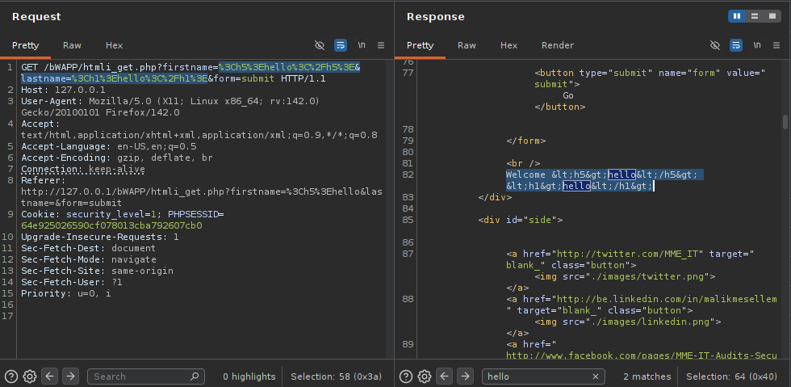  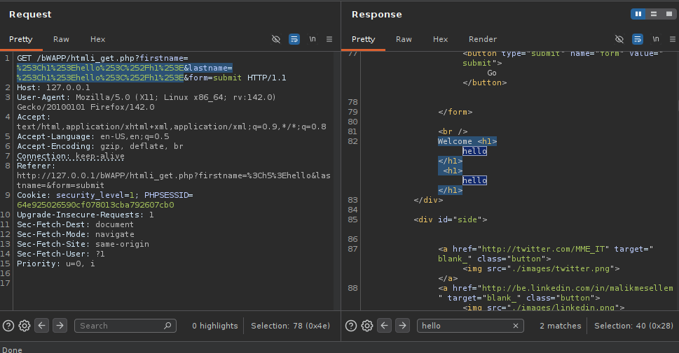  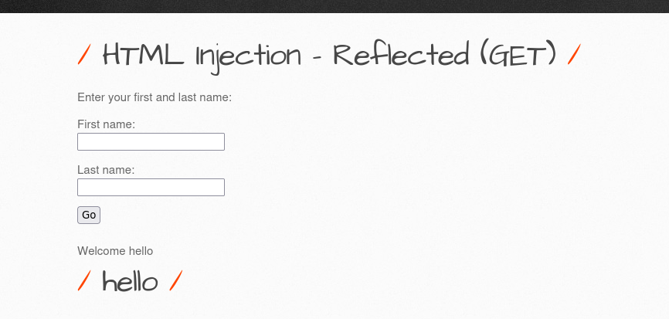
 12 Impact Analysis | Successful exploitation may allow attackers to:  - Manipulate website content.  - Modify page appearance.  - Insert deceptive messages.  - Conduct phishing attacks.  - Perform social engineering attacks.  - Reduce user trust in the application.  Although JavaScript execution was not observed during testing, HTML Injection may facilitate further client-side attacks when combined with additional vulnerabilities.
 13 Root cause | The vulnerability exists because the application:  - Performs inadequate server-side validation.  - Relies on blacklist-based filtering mechanisms.  - Fails to apply proper output encoding before rendering user-controlled content.  - Decodes URL-encoded input without securely sanitizing the resulting content.
 14 Remediation Steps | Immediate Fixes  Apply context-aware output encoding.  Treat all user input as untrusted.  Encode HTML special characters before rendering output.  Secure Coding Recommendations  Additional Security Controls  Implement allowlist validation.  Utilize secure templating engines.  Conduct regular security assessments.  Perform code reviews for injection vulnerabilities.
 15 References | https://owasp.org/www-project-web-security-testing-guide/latest/4-Web_Application_Security_Testing/11-Client-side_Testing/03-Testing_for_HTML_Injection

bWAPP VAPT  Assessment | VULNERABILITY REPORT | Report id : 2026-002  Date : 17 june  Tester : Abhijeet

 1 Vulnerability name | Cleartext Submission of Password
 2 severity level | High
 3 CVSS Score | 8.1 high
 4 Discription | The application login page uses an HTTP connection instead of HTTPS. Sensitive authentication credentials entered by users are transmitted over the network without transport-layer encryption.  The login form contains a password field and submits user credentials directly to:  http://127.0.0.1/bWAPP/login.php  The following form elements were identified:  <form action="/bWAPP/login.php" method="POST">  <input type="password"  id="password"  name="password"  size="20"  autocomplete="off">  Because SSL/TLS is not enforced, an attacker positioned on the network path may capture credentials during transmission.
 5 Affected Function / Parameter/URL | http://127.0.0.1/bWAPP/login.php
 6 Vulnerability Discovery Methodology | Reconnaissance-  The authentication functionality was identified as a high-value target because it processes user credentials.  Traffic Inspection-  Browser traffic was routed through Burp Suite Proxy to observe communication between the client and application.  Authentication Testing-  Valid credentials were entered into the login form and submitted to the application.  Verification-  The login request was observed being transmitted over HTTP instead of HTTPS.  The password parameter was visible within intercepted requests, confirming that sensitive authentication data was being transmitted without encryption.
 7 Tools Used | Firefox Browser Application Access  Burp Suite Traffic Analysis  Browser Developer Tools Client-side Inspection  Network Analyzer Traffic Verification
 8 Payloads used | null
 9 Steps to Reproduce | Step 1  Open the following URL in a browser:  - http://127.0.0.1/bWAPP/login.php  Step 2  - Configure the browser to route traffic through Burp Suite Proxy.  Step 3  - Enter valid application credentials.  Step 4  - Submit the login request.  Step 5  - Observe the intercepted request within Burp Suite.  Step 6  Verify that:  - Communication occurs over HTTP.  - Credentials are transmitted without TLS encryption.  - The password parameter is visible within the request.  Step 7  - Confirm successful authentication while traffic remains unencrypted.
 10 HTTP Reqest & Response | HTTP Request (Modified) | HTTP Response
 | POST /bWAPP/login.php HTTP/1.1  Host: 127.0.0.1  Content-Type: application/x-www-form-urlencoded  Cookie: security_level=2; PHPSESSID=166a8d2c407cc22effa21e57b149e34d  login=bee&password=a'a%5c'b%22c%3e%3f%3e%25%7d%7d%25%25%3ec%3c[[%3f$%7b%7b%25%7d%7dcake%5c&security_level=2&form=submit | HTTP/1.1 200 OK  Date: Tue, 23 Jun 2026 04:12:07 GMT  Server: Apache/2.4.67 (Debian)  Expires: Thu, 19 Nov 1981 08:52:00 GMT  Cache-Control: no-store, no-cache, must-revalidate  Pragma: no-cache  Vary: Accept-Encoding  Content-Length: 4086  Keep-Alive: timeout=5, max=100  Connection: Keep-Alive  Content-Type: text/html; charset=UTF-8  <html>  <form action="/bWAPP/login.php" method="POST">  <input type="password" id="password" name="password" size="20" autocomplete="off">  </html>
 11 Proof of Concept | 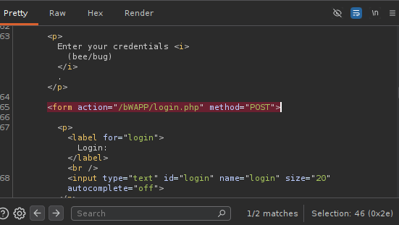  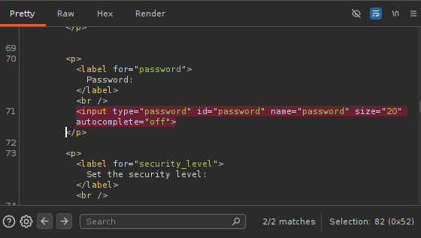
 12 Impact Analysis | Successful exploitation may allow attackers to:  Credential Theft  - Capture usernames and passwords transmitted across the network.  Account Compromise  - Authenticate as legitimate users using stolen credentials.  Privilege Escalation  - Gain unauthorized access to privileged functionality.  Password Reuse Attacks  - Leverage stolen passwords against other services where users reuse credentials.  Session Hijacking  - Capture authentication-related data and impersonate users.  Loss of Confidentiality  - Sensitive information may be disclosed to unauthorized parties.
 13 Root cause | The vulnerability exists because:  - The application uses HTTP instead of HTTPS.  - SSL/TLS encryption is not enforced.  - Sensitive authentication data is transmitted in cleartext.  - Secure transport mechanisms have not been implemented for the authentication workflow.
 14 Remediation Steps | Immediate Fixes  - Enforce HTTPS across the entire application.  - Redirect all HTTP requests to HTTPS.  - Install a valid SSL/TLS certificate.  - Disable plaintext authentication channels.  Session Security Controls  - Mark session cookies with:  - Secure  - HttpOnly  - SameSite  - Prevent transmission of session identifiers over HTTP.  Additional Security Recommendations  - Implement HTTP Strict Transport Security (HSTS).  - Use TLS 1.2 or TLS 1.3 only.  - Disable weak SSL/TLS protocols.  - Periodically review SSL/TLS configurations.
 15 References | - CWE-319: Cleartext Transmission of Sensitive Information  - CAPEC-117: Interception  - OWASP ASVS V9: Communications Security  - OWASP Top 10 2021 - A02 Cryptographic Failures

bWAPP VAPT  Assessment | VULNERABILITY REPORT | Report id : 2026-003  Date : 17 june  Tester : Abhijeet

 1 Vulnerability name | Reflected User-Controlled Input in URL Path
 2 severity level | Informational
 3 CVSS Score | 0.0(informational)
 4 Discription | The application reflects user-supplied URL path content within the response page.  Testing confirmed that URL-encoded input is decoded and displayed to the user. Although HTML tags appear within the reflected output, the browser does not interpret the tags as HTML elements.  For example:  Input:  /bWAPP/htmli_current_url.php/%3Ch1%3Ehello%3C%2Fh1%3E  Displayed Output:  <h1>hello</h1>  The tags were displayed as text rather than rendered as a heading element.  As a result, no active HTML Injection vulnerability could be confirmed.
 5 Affected Function / Parameter
 6 Vulnerability Discovery Methodology
 7 Tools Used | - Firefox Browser Manual Testing  - Burp Suite Traffic Inspection  - Browser Developer Tools Response Analysis
 8 Payloads used | <h1>hello</h1>  &lt;h1&gt;&sol;hello&lt;&sol;h1&gt;
 9 Steps to Reproduce | Step 1:- Navigate to the vulnerable functionality:  HTML Injection - Reflected (URL)  Step 2:- Append user-controlled content to the URL.  Example: /bWAPP/htmli_current_url.php/test  Step 3:- Observe that the application reflects the supplied content within the page.  Step 4:- Submit html-encoded HTML payloads.  Example: &lt;h1&gt;&sol;hello&lt;&sol;h1&gt;  Step 5:- Observe application behavior.  Step 6:- Verify whether the browser renders the injected tags as actual HTML elements.  Step 7:-Confirm that HTML tags are displayed as text and not interpreted by the browser.
 10 HTTP Reqest & Response | HTTP Request (Modified) | HTTP Response(Modified)
 | GET /bWAPP/htmli_current_url.php/&lt;h1&gt;&sol;hello&lt;&sol;h1&gt; HTTP/1.1  Host: 127.0.0.1  Cookie: security_level=0; PHPSESSID=1cf56c7189a8cdb7113a68e986137f1c | HTTP/1.1 200 OK  Content-Type: text/html  <p align="left">Your current URL: <i>http://127.0.0.1/bWAPP/htmli_current_url.php/&lt;h1&gt;&sol;hello&lt;&sol;h1&gt;</i></p>
 11 Proof of Concept | 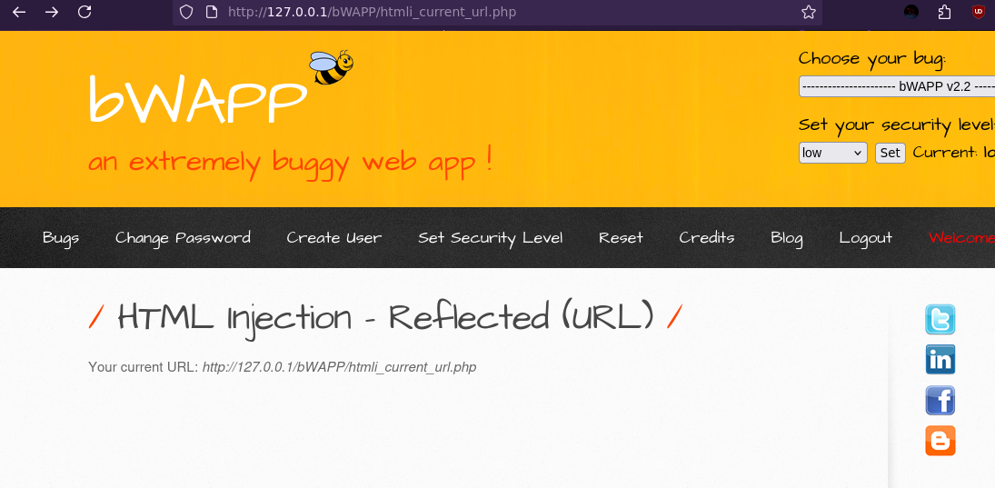  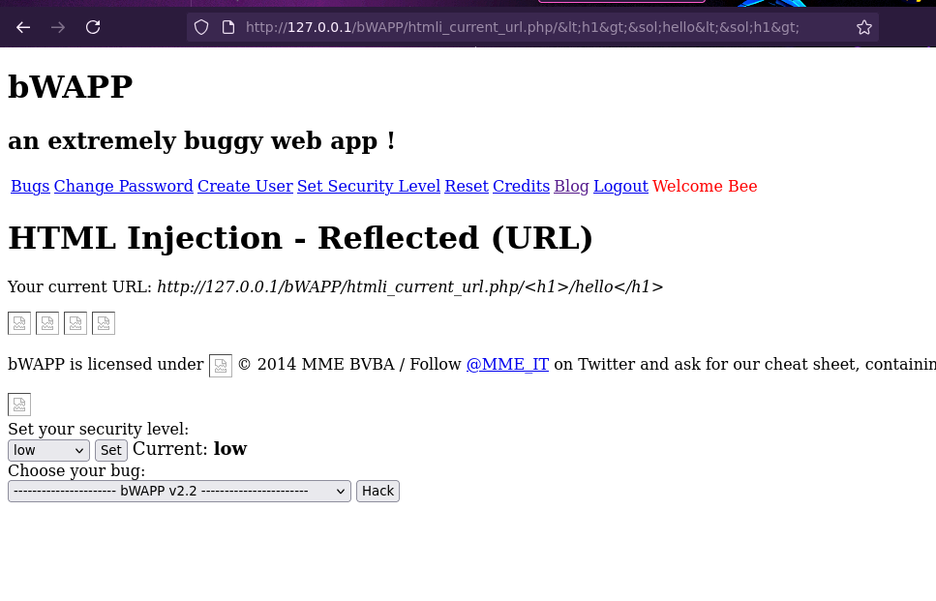
 12 Impact Analysis | Observed Impact  - Reflection of user-controlled input.  - Potential information disclosure regarding application processing logic.  Not Observed  - HTML rendering.  - CSS injection.  - JavaScript execution.  - DOM manipulation.  - Session compromise.  - Client-side code execution.
 13 Root cause | The application reflects user-supplied input without fully sanitizing the displayed content.  Although output encoding prevents browser interpretation of HTML tags, reflected content remains visible within the response page.  The observed styling issues occurred because modification of the URL path caused relative resource references (CSS and images) to fail, rather than as a result of successful HTML Injection.
 14 Remediation Steps | - Apply consistent output encoding for reflected user input.  - Avoid reflecting unnecessary user-controlled content.  - Use absolute paths for static resources where appropriate.  - Validate URL path components before displaying them within application responses.  - Implement centralized input validation and output encoding controls.
 15 References | - CWE-116 Improper Encoding or Escaping of Output  - https://owasp.org/Top10/  - https://owasp.org/www-project-web-security-testing-guide/  - https://cheatsheetseries.owasp.org/

bWAPP VAPT  Assessment | VULNERABILITY REPORT | Report id : 2026-001  Date : 17 june  Tester : Abhijeet

 1 Vulnerability name
 2 severity level | High
 3 CVSS Score
 4 Discription
 5 Affected Function / Parameter
 6 Vulnerability Discovery Methodology
 7 Tools Used
 8 Payloads used
 9 Steps to Reproduce
 10 HTTP Reqest & Response | HTTP Request (Modified) | HTTP Response
 11 Proof of Concept
 12 Impact Analysis
 13 Root cause
 14 Remediation Steps
 15 References

bWAPP VAPT  Assessment | VULNERABILITY REPORT | Report id : 2026-001  Date : 17 june  Tester : Abhijeet

 1 Vulnerability name
 2 severity level | High
 3 CVSS Score
 4 Discription
 5 Affected Function / Parameter
 6 Vulnerability Discovery Methodology
 7 Tools Used
 8 Payloads used
 9 Steps to Reproduce
 10 HTTP Reqest & Response | HTTP Request (Modified) | HTTP Response
 11 Proof of Concept
 12 Impact Analysis
 13 Root cause
 14 Remediation Steps
 15 References

bWAPP VAPT  Assessment | VULNERABILITY REPORT | Report id : 2026-001  Date : 17 june  Tester : Abhijeet

 1 Vulnerability name
 2 severity level | High
 3 CVSS Score
 4 Discription
 5 Affected Function / Parameter
 6 Vulnerability Discovery Methodology
 7 Tools Used
 8 Payloads used
 9 Steps to Reproduce
 10 HTTP Reqest & Response | HTTP Request (Modified) | HTTP Response
 11 Proof of Concept
 12 Impact Analysis
 13 Root cause
 14 Remediation Steps
 15 References

bWAPP VAPT  Assessment | VULNERABILITY REPORT | Report id : 2026-001  Date : 17 june  Tester : Abhijeet

 1 Vulnerability name
 2 severity level | High
 3 CVSS Score
 4 Discription
 5 Affected Function / Parameter
 6 Vulnerability Discovery Methodology
 7 Tools Used
 8 Payloads used
 9 Steps to Reproduce
 10 HTTP Reqest & Response | HTTP Request (Modified) | HTTP Response
 11 Proof of Concept
 12 Impact Analysis
 13 Root cause
 14 Remediation Steps
 15 References

bWAPP VAPT  Assessment | VULNERABILITY REPORT | Report id : 2026-001  Date : 17 june  Tester : Abhijeet

 1 Vulnerability name
 2 severity level | High
 3 CVSS Score
 4 Discription
 5 Affected Function / Parameter
 6 Vulnerability Discovery Methodology
 7 Tools Used
 8 Payloads used
 9 Steps to Reproduce
 10 HTTP Reqest & Response | HTTP Request (Modified) | HTTP Response
 11 Proof of Concept
 12 Impact Analysis
 13 Root cause
 14 Remediation Steps
 15 References

bWAPP VAPT  Assessment | VULNERABILITY REPORT | Report id : 2026-001  Date : 17 june  Tester : Abhijeet

 1 Vulnerability name
 2 severity level | High
 3 CVSS Score
 4 Discription
 5 Affected Function / Parameter
 6 Vulnerability Discovery Methodology
 7 Tools Used
 8 Payloads used
 9 Steps to Reproduce
 10 HTTP Reqest & Response | HTTP Request (Modified) | HTTP Response
 11 Proof of Concept
 12 Impact Analysis
 13 Root cause
 14 Remediation Steps
 15 References

bWAPP VAPT  Assessment | VULNERABILITY REPORT | Report id : 2026-001  Date : 17 june  Tester : Abhijeet

 1 Vulnerability name
 2 severity level | High
 3 CVSS Score
 4 Discription
 5 Affected Function / Parameter
 6 Vulnerability Discovery Methodology
 7 Tools Used
 8 Payloads used
 9 Steps to Reproduce
 10 HTTP Reqest & Response | HTTP Request (Modified) | HTTP Response
 11 Proof of Concept
 12 Impact Analysis
 13 Root cause
 14 Remediation Steps
 15 References

bWAPP VAPT  Assessment | VULNERABILITY REPORT | Report id : 2026-001  Date : 17 june  Tester : Abhijeet

 1 Vulnerability name
 2 severity level | High
 3 CVSS Score
 4 Discription
 5 Affected Function / Parameter
 6 Vulnerability Discovery Methodology
 7 Tools Used
 8 Payloads used
 9 Steps to Reproduce
 10 HTTP Reqest & Response | HTTP Request (Modified) | HTTP Response
 11 Proof of Concept
 12 Impact Analysis
 13 Root cause
 14 Remediation Steps
 15 References

bWAPP VAPT  Assessment | VULNERABILITY REPORT | Report id : 2026-001  Date : 17 june  Tester : Abhijeet

 1 Vulnerability name
 2 severity level | High
 3 CVSS Score
 4 Discription
 5 Affected Function / Parameter
 6 Vulnerability Discovery Methodology
 7 Tools Used
 8 Payloads used
 9 Steps to Reproduce
 10 HTTP Reqest & Response | HTTP Request (Modified) | HTTP Response
 11 Proof of Concept
 12 Impact Analysis

 13 Root cause
 14 Remediation Steps
 15 References

bWAPP VAPT  Assessment | VULNERABILITY REPORT | Report id : 2026-001  Date : 17 june  Tester : Abhijeet

 1 Vulnerability name
 2 severity level | High
 3 CVSS Score
 4 Discription
 5 Affected Function / Parameter
 6 Vulnerability Discovery Methodology
 7 Tools Used
 8 Payloads used
 9 Steps to Reproduce
 10 HTTP Reqest & Response | HTTP Request (Modified) | HTTP Response
 11 Proof of Concept
 12 Impact Analysis
 13 Root cause
 14 Remediation Steps
 15 References

bWAPP VAPT  Assessment | VULNERABILITY REPORT | Report id : 2026-001  Date : 17 june  Tester : Abhijeet

 1 Vulnerability name
 2 severity level | High
 3 CVSS Score
 4 Discription
 5 Affected Function / Parameter
 6 Vulnerability Discovery Methodology
 7 Tools Used
 8 Payloads used
 9 Steps to Reproduce
 10 HTTP Reqest & Response | HTTP Request (Modified) | HTTP Response
 11 Proof of Concept
 12 Impact Analysis
 13 Root cause
 14 Remediation Steps
 15 References

bWAPP VAPT  Assessment | VULNERABILITY REPORT | Report id : 2026-001  Date : 17 june  Tester : Abhijeet

 1 Vulnerability name
 2 severity level | High
 3 CVSS Score
 4 Discription
 5 Affected Function / Parameter
 6 Vulnerability Discovery Methodology
 7 Tools Used
 8 Payloads used
 9 Steps to Reproduce
 10 HTTP Reqest & Response | HTTP Request (Modified) | HTTP Response
 11 Proof of Concept
 12 Impact Analysis
 13 Root cause
 14 Remediation Steps
 15 References

bWAPP VAPT  Assessment | VULNERABILITY REPORT | Report id : 2026-001  Date : 17 june  Tester : Abhijeet

 1 Vulnerability name
 2 severity level | High
 3 CVSS Score
 4 Discription
 5 Affected Function / Parameter
 6 Vulnerability Discovery Methodology
 7 Tools Used
 8 Payloads used
 9 Steps to Reproduce
 10 HTTP Reqest & Response | HTTP Request (Modified) | HTTP Response
 11 Proof of Concept
 12 Impact Analysis
 13 Root cause
 14 Remediation Steps
 15 References

bWAPP VAPT  Assessment | VULNERABILITY REPORT | Report id : 2026-001  Date : 17 june  Tester : Abhijeet

 1 Vulnerability name
 2 severity level | High
 3 CVSS Score
 4 Discription
 5 Affected Function / Parameter
 6 Vulnerability Discovery Methodology
 7 Tools Used
 8 Payloads used
 9 Steps to Reproduce
 10 HTTP Reqest & Response | HTTP Request (Modified) | HTTP Response
 11 Proof of Concept
 12 Impact Analysis
 13 Root cause
 14 Remediation Steps
 15 References

bWAPP VAPT  Assessment | VULNERABILITY REPORT | Report id : 2026-001  Date : 17 june  Tester : Abhijeet

 1 Vulnerability name
 2 severity level | High
 3 CVSS Score
 4 Discription
 5 Affected Function / Parameter
 6 Vulnerability Discovery Methodology
 7 Tools Used
 8 Payloads used
 9 Steps to Reproduce
 10 HTTP Reqest & Response | HTTP Request (Modified) | HTTP Response
 11 Proof of Concept
 12 Impact Analysis
 13 Root cause
 14 Remediation Steps
 15 References

bWAPP VAPT  Assessment | VULNERABILITY REPORT | Report id : 2026-001  Date : 17 june  Tester : Abhijeet

 1 Vulnerability name
 2 severity level | High
 3 CVSS Score
 4 Discription
 5 Affected Function / Parameter
 6 Vulnerability Discovery Methodology
 7 Tools Used
 8 Payloads used
 9 Steps to Reproduce
 10 HTTP Reqest & Response | HTTP Request (Modified) | HTTP Response
 11 Proof of Concept
 12 Impact Analysis
 13 Root cause
 14 Remediation Steps
 15 References

bWAPP VAPT  Assessment | VULNERABILITY REPORT | Report id : 2026-001  Date : 17 june  Tester : Abhijeet

 1 Vulnerability name
 2 severity level | High
 3 CVSS Score
 4 Discription
 5 Affected Function / Parameter
 6 Vulnerability Discovery Methodology
 7 Tools Used
 8 Payloads used
 9 Steps to Reproduce
 10 HTTP Reqest & Response | HTTP Request (Modified) | HTTP Response
 11 Proof of Concept
 12 Impact Analysis
 13 Root cause
 14 Remediation Steps
 15 References

bWAPP VAPT  Assessment | VULNERABILITY REPORT | Report id : 2026-001  Date : 17 june  Tester : Abhijeet

 1 Vulnerability name
 2 severity level | High
 3 CVSS Score
 4 Discription
 5 Affected Function / Parameter
 6 Vulnerability Discovery Methodology
 7 Tools Used
 8 Payloads used
 9 Steps to Reproduce
 10 HTTP Reqest & Response | HTTP Request (Modified) | HTTP Response
 11 Proof of Concept
 12 Impact Analysis
 13 Root cause
 14 Remediation Steps
 15 References

bWAPP VAPT  Assessment | VULNERABILITY REPORT | Report id : 2026-001  Date : 17 june  Tester : Abhijeet

 1 Vulnerability name
 2 severity level | High
 3 CVSS Score
 4 Discription
 5 Affected Function / Parameter
 6 Vulnerability Discovery Methodology
 7 Tools Used
 8 Payloads used
 9 Steps to Reproduce
 10 HTTP Reqest & Response | HTTP Request (Modified) | HTTP Response
 11 Proof of Concept
 12 Impact Analysis
 13 Root cause
 14 Remediation Steps
 15 References

bWAPP VAPT  Assessment | VULNERABILITY REPORT | Report id : 2026-001  Date : 17 june  Tester : Abhijeet

 1 Vulnerability name
 2 severity level | High
 3 CVSS Score
 4 Discription
 5 Affected Function / Parameter
 6 Vulnerability Discovery Methodology
 7 Tools Used
 8 Payloads used
 9 Steps to Reproduce
 10 HTTP Reqest & Response | HTTP Request (Modified) | HTTP Response
 11 Proof of Concept
 12 Impact Analysis
 13 Root cause
 14 Remediation Steps
 15 References

bWAPP VAPT  Assessment | VULNERABILITY REPORT | Report id : 2026-001  Date : 17 june  Tester : Abhijeet

 1 Vulnerability name
 2 severity level | High
 3 CVSS Score
 4 Discription
 5 Affected Function / Parameter
 6 Vulnerability Discovery Methodology
 7 Tools Used
 8 Payloads used
 9 Steps to Reproduce
 10 HTTP Reqest & Response | HTTP Request (Modified) | HTTP Response
 11 Proof of Concept
 12 Impact Analysis
 13 Root cause
 14 Remediation Steps
 15 References

bWAPP VAPT  Assessment | VULNERABILITY REPORT | Report id : 2026-001  Date : 17 june  Tester : Abhijeet

 1 Vulnerability name
 2 severity level | High
 3 CVSS Score
 4 Discription
 5 Affected Function / Parameter
 6 Vulnerability Discovery Methodology
 7 Tools Used
 8 Payloads used
 9 Steps to Reproduce
 10 HTTP Reqest & Response | HTTP Request (Modified) | HTTP Response
 11 Proof of Concept
 12 Impact Analysis

 13 Root cause
 14 Remediation Steps
 15 References

bWAPP VAPT  Assessment | VULNERABILITY REPORT | Report id : 2026-001  Date : 17 june  Tester : Abhijeet

 1 Vulnerability name
 2 severity level | High
 3 CVSS Score
 4 Discription
 5 Affected Function / Parameter
 6 Vulnerability Discovery Methodology
 7 Tools Used
 8 Payloads used
 9 Steps to Reproduce
 10 HTTP Reqest & Response | HTTP Request (Modified) | HTTP Response
 11 Proof of Concept
 12 Impact Analysis
 13 Root cause
 14 Remediation Steps
 15 References

bWAPP VAPT  Assessment | VULNERABILITY REPORT | Report id : 2026-001  Date : 17 june  Tester : Abhijeet

 1 Vulnerability name
 2 severity level | High
 3 CVSS Score
 4 Discription
 5 Affected Function / Parameter
 6 Vulnerability Discovery Methodology
 7 Tools Used
 8 Payloads used
 9 Steps to Reproduce
 10 HTTP Reqest & Response | HTTP Request (Modified) | HTTP Response
 11 Proof of Concept
 12 Impact Analysis
 13 Root cause
 14 Remediation Steps
 15 References

bWAPP VAPT  Assessment | VULNERABILITY REPORT | Report id : 2026-001  Date : 17 june  Tester : Abhijeet

 1 Vulnerability name
 2 severity level | High
 3 CVSS Score
 4 Discription
 5 Affected Function / Parameter
 6 Vulnerability Discovery Methodology
 7 Tools Used
 8 Payloads used
 9 Steps to Reproduce
 10 HTTP Reqest & Response | HTTP Request (Modified) | HTTP Response
 11 Proof of Concept
 12 Impact Analysis
 13 Root cause
 14 Remediation Steps
 15 References

bWAPP VAPT  Assessment | VULNERABILITY REPORT | Report id : 2026-001  Date : 17 june  Tester : Abhijeet

 1 Vulnerability name
 2 severity level | High
 3 CVSS Score
 4 Discription
 5 Affected Function / Parameter
 6 Vulnerability Discovery Methodology
 7 Tools Used
 8 Payloads used
 9 Steps to Reproduce
 10 HTTP Reqest & Response | HTTP Request (Modified) | HTTP Response
 11 Proof of Concept
 12 Impact Analysis
 13 Root cause
 14 Remediation Steps
 15 References

bWAPP VAPT  Assessment | VULNERABILITY REPORT | Report id : 2026-001  Date : 17 june  Tester : Abhijeet

 1 Vulnerability name
 2 severity level | High
 3 CVSS Score
 4 Discription
 5 Affected Function / Parameter
 6 Vulnerability Discovery Methodology
 7 Tools Used
 8 Payloads used
 9 Steps to Reproduce
 10 HTTP Reqest & Response | HTTP Request (Modified) | HTTP Response
 11 Proof of Concept
 12 Impact Analysis
 13 Root cause
 14 Remediation Steps
 15 References

bWAPP VAPT  Assessment | VULNERABILITY REPORT | Report id : 2026-001  Date : 17 june  Tester : Abhijeet

 1 Vulnerability name
 2 severity level | High
 3 CVSS Score
 4 Discription
 5 Affected Function / Parameter
 6 Vulnerability Discovery Methodology
 7 Tools Used
 8 Payloads used
 9 Steps to Reproduce
 10 HTTP Reqest & Response | HTTP Request (Modified) | HTTP Response
 11 Proof of Concept
 12 Impact Analysis
 13 Root cause
 14 Remediation Steps
 15 References

bWAPP VAPT  Assessment | VULNERABILITY REPORT | Report id : 2026-001  Date : 17 june  Tester : Abhijeet

 1 Vulnerability name
 2 severity level | High
 3 CVSS Score
 4 Discription
 5 Affected Function / Parameter
 6 Vulnerability Discovery Methodology
 7 Tools Used
 8 Payloads used
 9 Steps to Reproduce
 10 HTTP Reqest & Response | HTTP Request (Modified) | HTTP Response
 11 Proof of Concept
 12 Impact Analysis
 13 Root cause
 14 Remediation Steps
 15 References

bWAPP VAPT  Assessment | VULNERABILITY REPORT | Report id : 2026-001  Date : 17 june  Tester : Abhijeet

 1 Vulnerability name
 2 severity level | High
 3 CVSS Score
 4 Discription
 5 Affected Function / Parameter
 6 Vulnerability Discovery Methodology
 7 Tools Used
 8 Payloads used
 9 Steps to Reproduce
 10 HTTP Reqest & Response | HTTP Request (Modified) | HTTP Response
 11 Proof of Concept
 12 Impact Analysis
 13 Root cause
 14 Remediation Steps
 15 References

bWAPP VAPT  Assessment | VULNERABILITY REPORT | Report id : 2026-001  Date : 17 june  Tester : Abhijeet

 1 Vulnerability name
 2 severity level | High
 3 CVSS Score
 4 Discription
 5 Affected Function / Parameter
 6 Vulnerability Discovery Methodology
 7 Tools Used
 8 Payloads used
 9 Steps to Reproduce
 10 HTTP Reqest & Response | HTTP Request (Modified) | HTTP Response
 11 Proof of Concept
 12 Impact Analysis
 13 Root cause
 14 Remediation Steps
 15 References

bWAPP VAPT  Assessment | VULNERABILITY REPORT | Report id : 2026-001  Date : 17 june  Tester : Abhijeet

 1 Vulnerability name
 2 severity level | High
 3 CVSS Score
 4 Discription
 5 Affected Function / Parameter
 6 Vulnerability Discovery Methodology
 7 Tools Used
 8 Payloads used
 9 Steps to Reproduce
 10 HTTP Reqest & Response | HTTP Request (Modified) | HTTP Response
 11 Proof of Concept
 12 Impact Analysis
 13 Root cause
 14 Remediation Steps
 15 References

bWAPP VAPT  Assessment | VULNERABILITY REPORT | Report id : 2026-001  Date : 17 june  Tester : Abhijeet

 1 Vulnerability name
 2 severity level | High
 3 CVSS Score
 4 Discription
 5 Affected Function / Parameter
 6 Vulnerability Discovery Methodology
 7 Tools Used
 8 Payloads used
 9 Steps to Reproduce
 10 HTTP Reqest & Response | HTTP Request (Modified) | HTTP Response
 11 Proof of Concept
 12 Impact Analysis
 13 Root cause
 14 Remediation Steps
 15 References

bWAPP VAPT  Assessment | VULNERABILITY REPORT | Report id : 2026-001  Date : 17 june  Tester : Abhijeet

 1 Vulnerability name
 2 severity level | High
 3 CVSS Score
 4 Discription
 5 Affected Function / Parameter
 6 Vulnerability Discovery Methodology
 7 Tools Used
 8 Payloads used
 9 Steps to Reproduce
 10 HTTP Reqest & Response | HTTP Request (Modified) | HTTP Response
 11 Proof of Concept
 12 Impact Analysis
 13 Root cause
 14 Remediation Steps
 15 References

bWAPP VAPT  Assessment | VULNERABILITY REPORT | Report id : 2026-001  Date : 17 june  Tester : Abhijeet

 1 Vulnerability name
 2 severity level | High
 3 CVSS Score
 4 Discription
 5 Affected Function / Parameter
 6 Vulnerability Discovery Methodology
 7 Tools Used
 8 Payloads used
 9 Steps to Reproduce
 10 HTTP Reqest & Response | HTTP Request (Modified) | HTTP Response
 11 Proof of Concept
 12 Impact Analysis

 13 Root cause
 14 Remediation Steps
 15 References

bWAPP VAPT  Assessment | VULNERABILITY REPORT | Report id : 2026-001  Date : 17 june  Tester : Abhijeet

 1 Vulnerability name
 2 severity level | High
 3 CVSS Score
 4 Discription
 5 Affected Function / Parameter
 6 Vulnerability Discovery Methodology
 7 Tools Used
 8 Payloads used
 9 Steps to Reproduce
 10 HTTP Reqest & Response | HTTP Request (Modified) | HTTP Response
 11 Proof of Concept
 12 Impact Analysis
 13 Root cause
 14 Remediation Steps
 15 References

